Week 6

Skill name : React

Hands-on 1: Create a new React Application with the name “myfirstreact”, Run the application to print “welcome to the first session of React” as heading of that page.

#### Step 1:- Install create-react-app globally

Open **Command Prompt** or **Terminal** and run:

npm install -g create-react-app

npx create-react-app myfirstreact

Step 2:- Navigate into the project folder

//App.js

import React from 'react';

function App() {

return (

<div>

<h1>Welcome to the first session of React</h1>

</div>

);

}

export default App;

Output:-



Hands-on 2:

Create a react app for Student Management Portal named StudentApp and create a component named Home which will display the Message “Welcome to the Home page of Student Management Portal”. Create another component named About and display the Message “Welcome to the About page of the Student Management Portal”. Create a third component named Contact and display the Message “Welcome to the Contact page of the Student Management Portal”. Call all the three components.

Step 1:-

npx create-react-app StudentApp

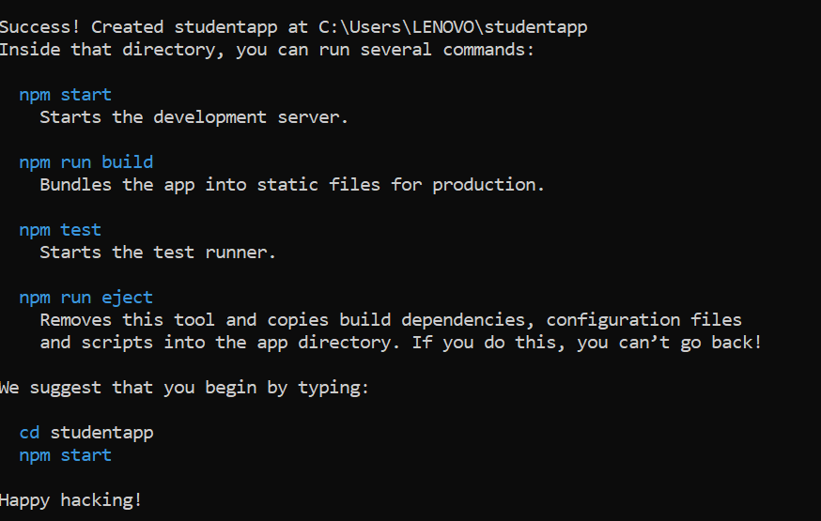

Step 2:-

//Home.js

import React from 'react';

function Home() {

return (

<div>

<h2>Welcome to the Home page of Student Management Portal</h2>

</div>

);

}

export default Home;

//About.js

import React from 'react';

function About() {

return (

<div>

<h2>Welcome to the About page of the Student Management Portal</h2>

</div>

);

}

export default About;

//Contact.js

import React from 'react';

function Contact() {

return (

<div>

<h2>Welcome to the Contact page of the Student Management Portal</h2>

</div>

);

}

export default Contact;

//App.js

import React from 'react';

import Home from './Components/Home';

import About from './Components/About';

import Contact from './Components/Contact';

function App() {

return (

<div className="App">

<Home />

<About />

<Contact />

</div>

);

}

export default App;

Output:-



Hands-on 3:-

Create a react app for Student Management Portal named scorecalculatorapp and create a function component named “CalculateScore” which will accept Name, School, Total and goal in order to calculate the average score of a student and display the same.

Step 1:

npx create-react-app scorecalculatorapp

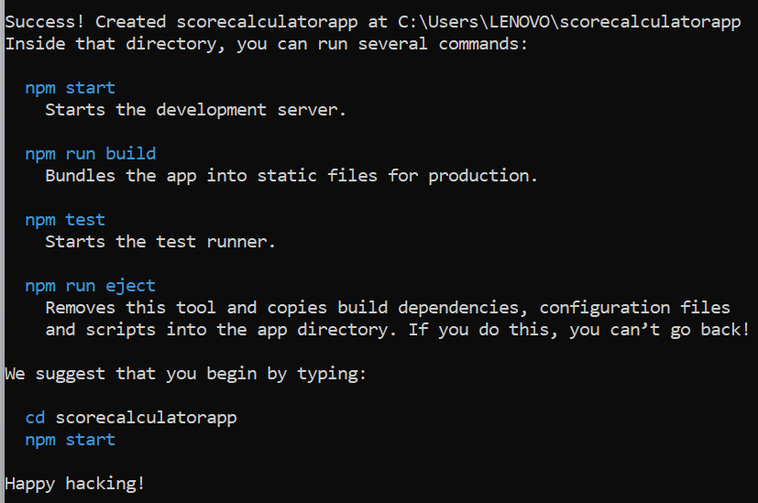//src/Components/CalculateScore.js

import React from 'react';

import '../Stylesheets/mystyle.css';

function CalculateScore() {

const name = "Ananya";

const school = "Green Valley High School";

const total = 450;

const goal = 500;

const average = (total / goal) * 100;

return (

<div className="score-container">

<h2>Student Score Report</h2>

<p><strong>Name:</strong> {name}</p>

<p><strong>School:</strong> {school}</p>

<p><strong>Total Marks:</strong> {total}</p>

<p><strong>Goal Marks:</strong> {goal}</p>

<p><strong>Average Score:</strong> {average.toFixed(2)}%</p>

</div>

);

}

export default CalculateScore;

//src/Stylesheets/mystyle.css

.score-container {

margin: 30px auto;

padding: 20px;

border: 2px solid #4caf50;

border-radius: 10px;

max-width: 500px;

background-color: #f9f9f9;

font-family: Arial, sans-serif;

box-shadow: 2px 2px 10px rgba(0,0,0,0.1);

}

.score-container h2 {

color: #2e7d32;

text-align: center;

}

.score-container p {

font-size: 16px;

margin: 8px 0;

}

//App.js

import React from 'react';

import './App.css';

import CalculateScore from './Components/CalculateScore';

function App() {

return (

<div className="App">

<CalculateScore />

</div>

);

}

export default App;

Output:-

